9.48: a) With 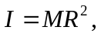with expression for v is
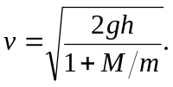
b) This expression is smaller than that for the solid cylinder; more of the cylinder’s mass is concentrated at its edge, so for a given speed, the kinetic energy of the cylinder is larger. A larger fraction of the potential energy is converted to the kinetic energy of the cylinder, and so less is available for the falling mass.

